National School Backpack Awareness Day
Wednesday, September (DATE/YEAR)
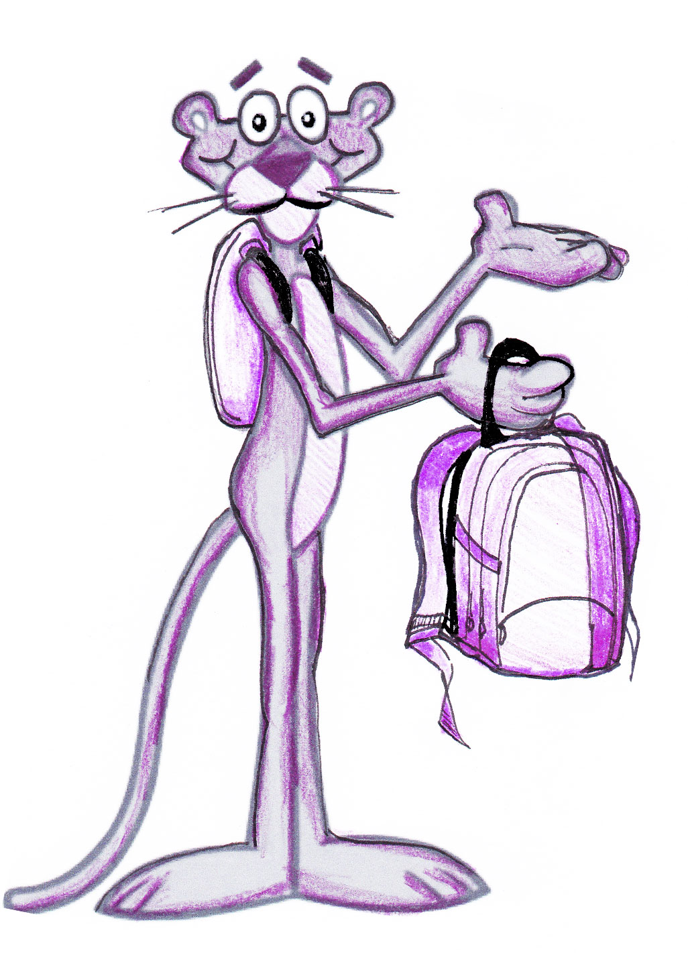
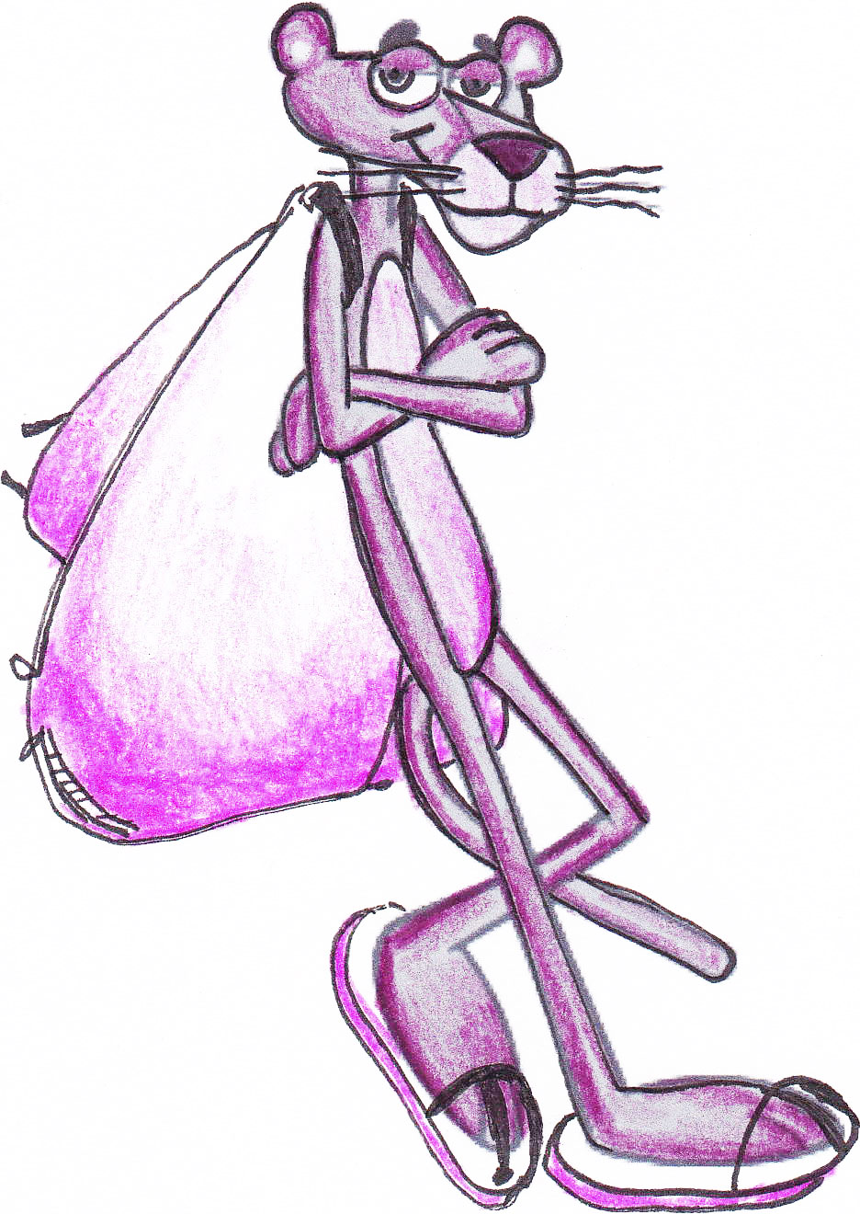
● Get your backpack weighed before school on (DATE)
● Discover if your backpack is an acceptable load for you to carry
● Learn how to select, pack and wear a backpack properly
● Ask the experts- (PT FIRM OR CHIRO NAME) will be in attendance
● Win PRIZES!
● Ask questions/join our committee: (EMAIL CONTACT)

Is your backpack’s weight within the acceptable range?
BACKPACK (______lb) / BODY WEIGHT (_______lb) x 100 = _________%

The AOTA and APTA recommend backpack load be no more than 10-15% of a child’s bodyweight

